**Defining the problem**

I am my own client and my problem is the lack of a proper structure to manage my homework and school tasks. I often do not remember my own homework leading to missed assignments. I sometimes forget to write down the work or forget dates. Even when I do write it down, it's often in a rush, so I leave things out or write on easy-to-lose scrap paper. These missing assignments cause issues like affecting grades, relationships with teachers and other difficulties. In addition, fixing overdue homework also causes complications that can take even more time. I also sometimes forget things to do in the day. One of the solutions to missing homework is I have to meet teachers, on rare occasions I can forget these meetings and other such tasks. The issue was rare enough when the workload was really low, but in recent years as all the work has increased all missing homework, lost deadline and number of meetings and activities to attend throughout the day. My current setup to keep track of tasks is memory or the occasional note on scrap paper which is very unreliable. This was mainly because of none of the systems such as having one notebook didn't work for various reasons such as just not having enough time to write, or it taking too long. Refer to Appendix Initial Reflection for more details.

Client: Me

Advisor: Mom (Software engineer)

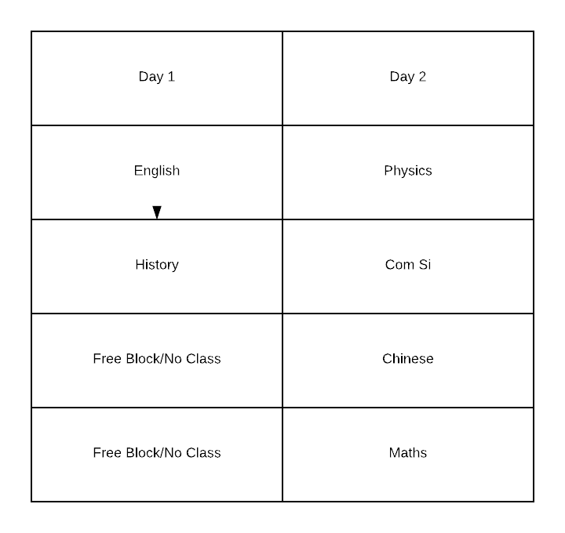

*Figure 1: My school schedule alternates between each ‘day’ everyday, every week is different including holidays. (i.e Monday is Day 1, hence Tuesday is Day 2)*

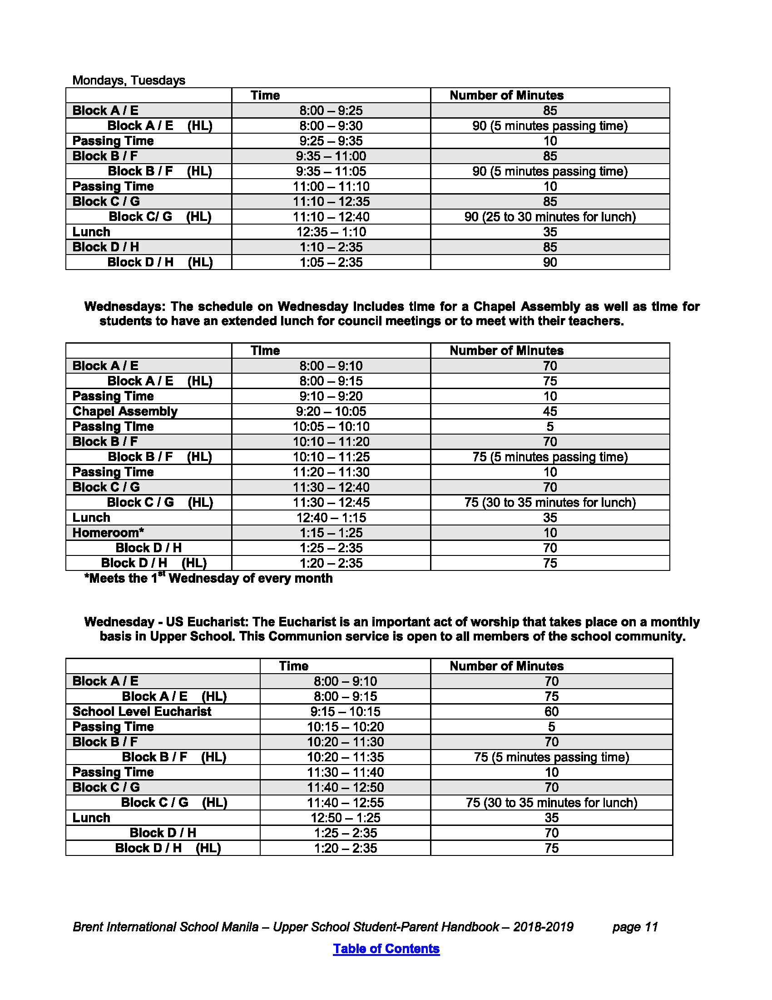

*Figure 2: School times for each block and start of the day are different almost per day*

**Rationale for Proposed Solution**

The Proposed solution is a bespoke Android app.

Because:

* My phone is always available and can be used with 1 hand.
* Laptops are more cumbersome and time-consuming
* A phone application is less hassle than a notebook and pen
* My phone has pre-built security features
* Android Apps can be made with XML and create a far more flexible UI which is more efficient and has more features than a standard Java desktop program

To solve this:

* The app would contain 2 modules
  + Homework and Class section
    - Store all classes and timings.
    - Store all homework.
    - Set alarms automatically that are dependent on classes and days
    - The alarms would be consistent with each day schedule and the schedule of that day of the week
  + Day Tasks
    - Set manual short terms alarms with minimal information for any unexpected purpose needed

Why other solutions do not work

* Evernote does not send active reminders
* Creating manual alarms for each day per week would remind on holidays and on free blocks, Manual alarms also take more time to set up than the proposed solution
* Wonderlist does not send active reminders
* No other app could manage all of
  + a flexible schedule which changes day by day and is not consistent between weeks
  + Each day has different alarms
  + Is free
  + Set manual short term alarms quickly

**Success Criteria**

* Application self automatedly reminds to enter homework on correct time and day for each class
* Application stores all homework and class information properly
* Application UI should be custom made for each requirement
* The application allows the creation of easy manual alarms
* Application accurately triggers all alarms

Words: 509